foster+freeman
FORENSIC SCIENCE INNOVATION
Author: Caiger
Email: martyn.caiger@fostrerfreeman.com
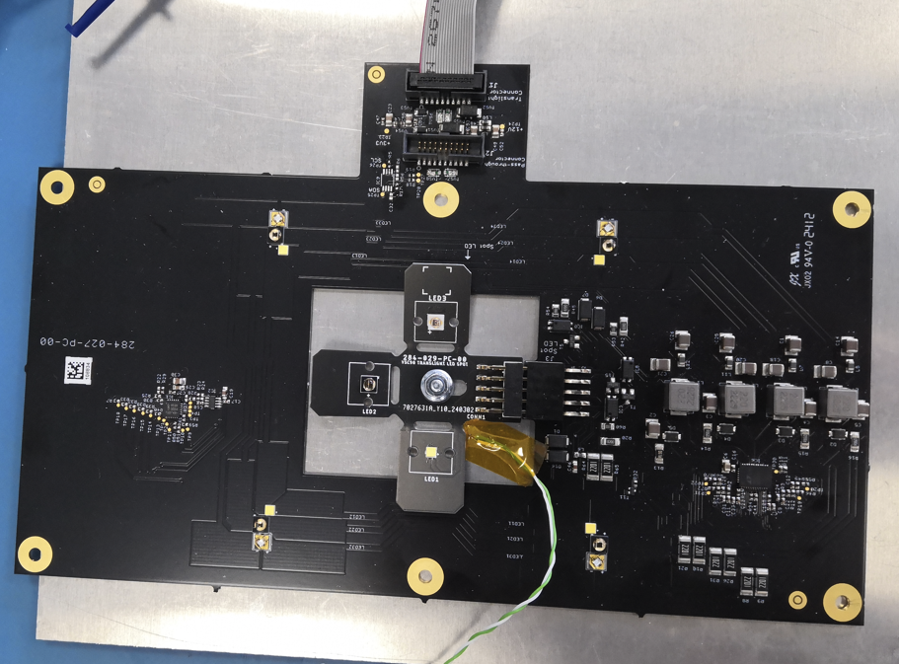
284-027 Translight pcb with 284-029 Spot Light Fitted
VSC90 Translight 284-027-PC-00
PCB Assembly Test Plan

FOR INTERNAL USE ONLY

Contents
2 Document History 3
3 Scope and Brief Circuit Description 3
4 Equipment List 3
4.1 Test Hardware 3
4.2 Test Software 4
5 Test Procedure 5
5.1 Power Supplies 5
5.2 Microcontrollers 6
5.3 Functional Tests 7
5.4 Functional Tests 2 7
5.5 USB 8
5.6 Serial Interfaces 9
5.7 Thermal 10
6 Modifications 10

5.7 Thermal 9 2
2 Document History 3
3 Scope AND BRIEF CIRCUIT DESCRIPTION 3
4 Equipment List 3
4.1 Test Hardware 3
4.2 Test Software 4
5 Test Procedure 5
5.1 Power Supplies 5
5.2 Microcontrollers 6
5.3 Functional Tests 7
5.4 Functional Tests 2 7
5.5 USB 8
5.6 Serial Interfaces 9
5.7 Thermal 10

Document History

Version | Date | Author | Description of changes
00 | 19/04/24 | Caiger | First Issue of prototype 284-027-PC-00

Scope AND BRIEF CIRCUIT DESCRIPTION
This document outlines the test plan for VSC90 Translight (284-027-PC-00) to verify that the design functions as intended on the bench.

NOTE: THIS TESTING IS DONE WITH A VERY STABLE BENCH PSU AND DOES NOT GUARANTEE THAT THERE WILL NOT BE PROBLEMS WHEN INTEGRATED INTO THE VSC90 WITH A LOWER QUALITY PSU AND LONG RIBBON CABLE LENGTHS FOR THE COMMON INTERFACE POWER AND COMMS CONNECTION.

Pcb consists of a 4 channel led string driver driving 3 separate led strings (Flood: White, IR850nm, UV 365nm) of 4 leds and a separate Spotlight PCB (284-029-PC-00) which has 3 individually switchable leds: White, 850nm, 780nm.
A 2 Output DAC dims the Spotlight and White Flood with Output1 and IR850 Flood, UV365 Flood with Output2. Pcb drive voltage of 12V, 3V3 and I2C communication is through the common Interface connector J1 or J2.

Power and Comms supplied through the Common Interface ribbon connector.

NOTE: in order to get the I2C comms running reliably the board had to have the I2C TVS components replaced with lower capacitance devices and 10K pull-ups added: SEE SECTION 6 MODIFICATIONS

Equipment List

Test Hardware

ID | Description | Quantity | Serial Number
[H01] | Calibrated Digital 4 Channel Oscilloscope with min 100Mhz response 10:1 10MΩ probes | 1 | N/A
[H02] | Calibrated 2 Channel PSU 0-30VDC 5A Eg: Tenma T2-10495. (3A would be OK – may need additional output capacitor to deal with inrush at pcb start-up to prevent PSU current limiting) | 1 | N/A
[H03] | Sparkfun Bus Pirate USB to serial device (USB to I2C in this instance) | 1 | N/A
[H04] | Calibrated minimum 3.5 Digital Volt Meter | 1 | N/A
 | Schematic and Board Files for 284-027-PC-00 | 1 | N/A

Test Software

ID | Description | Version
[S01] | COMport (to input I2C commands to operate 2 output DAC and 16 way GPIO) | V1.01.19

COMport (baud rate set 115K) Text for Bus Pirate(Arrrgh..copyright) to I2C comms: Bus Pirate(Arrrgh..copyright) configure Commands: m4\n3 (changes comms mode to option4: I2C comms\ option 3: CLK speed 100KHz)

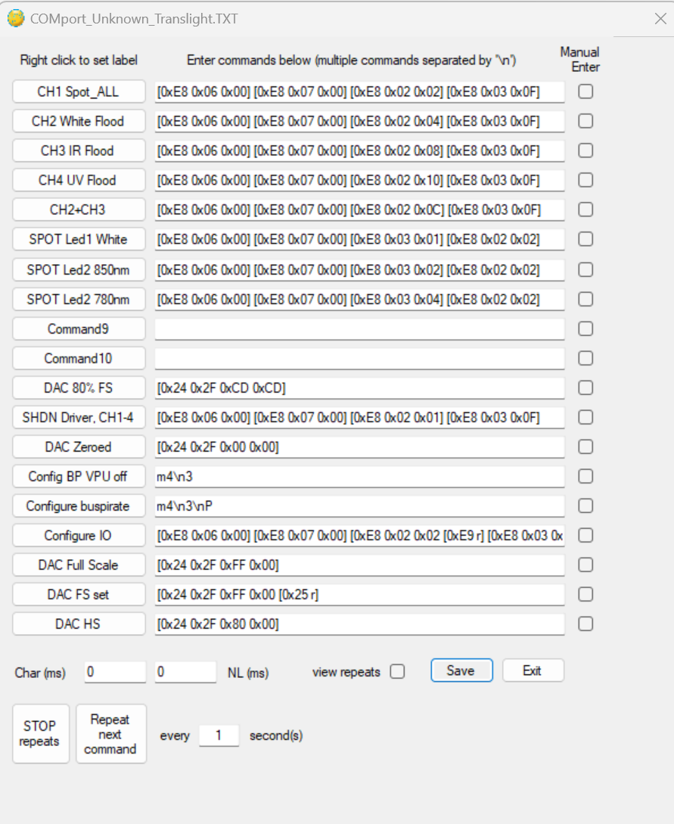

For Test Dept: next page will give the text which can be copied for appropriate I2C commands.
For individual Spot leds I have reversed the GPIO port write sequence to set the Spot Led Shunt Fets before turning on the string driver so that there is no unwanted momentary flash from the other spot leds during the turn on sequence.

COMport text file Tranlight.txt

"CH1 Spot_ALL"=[0xE8 0x06 0x00] [0xE8 0x07 0x00] [0xE8 0x02 0x02] [0xE8 0x03 0x0F]\n
"CH2 White Flood"=[0xE8 0x06 0x00] [0xE8 0x07 0x00] [0xE8 0x02 0x04] [0xE8 0x03 0x0F]\n
"CH3 IR Flood"=[0xE8 0x06 0x00] [0xE8 0x07 0x00] [0xE8 0x02 0x08] [0xE8 0x03 0x0F]\n
"CH4 UV Flood"=[0xE8 0x06 0x00] [0xE8 0x07 0x00] [0xE8 0x02 0x10] [0xE8 0x03 0x0F]\n
"CH2+CH3"=[0xE8 0x06 0x00] [0xE8 0x07 0x00] [0xE8 0x02 0x0C] [0xE8 0x03 0x0F]\n
"SPOT Led1 White"=[0xE8 0x06 0x00] [0xE8 0x07 0x00] [0xE8 0x03 0x01] [0xE8 0x02 0x02]\n
"SPOT Led2 850nm"=[0xE8 0x06 0x00] [0xE8 0x07 0x00] [0xE8 0x03 0x02] [0xE8 0x02 0x02]\n
"SPOT Led2 780nm"=[0xE8 0x06 0x00] [0xE8 0x07 0x00] [0xE8 0x03 0x04] [0xE8 0x02 0x02]\n
"Command9"=\n
"Command10"=\n
"DAC 80% FS"=[0x24 0x2F 0xCD 0xCD]\n
"SHDN Driver, CH1-4"=[0xE8 0x06 0x00] [0xE8 0x07 0x00] [0xE8 0x02 0x01] [0xE8 0x03 0x0F]\n
"DAC Zeroed"=[0x24 0x2F 0x00 0x00]\n
"Config BP VPU off"=m4\n3\n
"Configure buspirate"=m4\n3\nP\n
"Configure IO"=[0xE8 0x06 0x00] [0xE8 0x07 0x00] [0xE8 0x02 0x02 [0xE9 r] [0xE8 0x03 0x0F [0xE9 r]\n
"DAC Full Scale"=[0x24 0x2F 0xFF 0x00]\n
"DAC FS set"=[0x24 0x2F 0xFF 0x00 [0x25 r]\n
"DAC HS"=[0x24 0x2F 0x80 0x00]\n

Test Procedure

PCB Version Tested: | 284-027-AS-00

Power Supplies
- Pre-power up Checks  - Impedance of all voltage rails: 12V rail 380Ω, 3V3 rail 490KΩ. Led drive rails.0.8KΩ - 1KΩ (dependant on measurement direction  - Voltage Sources  - Output voltage N/A  - Output ripple N/A  - Power up output overshoot N/A  - Line regulation N/A  - Load regulation N/A  - Enable/Disable/UV lockout N/A  - Load test? N/A  - Short circuit protection (if load external) N/A | - Current Sources (SEE PWM LED DRIVES SECTION 5.3)  - Output Current (across expected load range)  - Open circuit protection/voltage  - Led Drives  - Power gating/E-fuses  - Check function of any additional power gating/FETs N/A  - E-fuse trip point, & Short circuit N/A

ID | Test | Limits/Criteria | Result | Comments
 | Using the DVM, measure the output voltage of the +3V3 rail. | 3.2 – 3.4 V | N/A
 | Using the Oscilloscope, measure the voltage ripple of the +3V3 rail. | < 100 mV | N/A
- | - Power off the UUT.  - Connect the scope to +3V3 (TP2), single trigger @ 1.6V.  - Power on the UUT. | - | N/A
 | Measure the peak overshoot voltage on +3V3 (TP2) using the Oscilloscope. | < 3.8 V | N/A

LT3476 4 Channels Led drive all drives operate with continuous 640KHz PWM waveform above a DAC value of 0x20 (below this runs discontinuous with pulse skipping but is not unstable, nor audible) max value of DAC 0xFF. No signs of instability at 0x80, 0xFF. Flood UV365 should not be operated above 80% PWM to stay within the PWM switching transistor current limits (the LT3476 driver is self limiting) and was tested at DAC 80%: 0xCD.

PWM waveforms checked at Vin of 11.0V, 12.0V, 13.0V at designated LED string Max Load and found to be stable:

0.625mA for Flood White, IR, White and IR together
500mA (80% DAC of 0.625mA) for Flood UV365
750mA for Spot Leds White, IR850, IR940 tested individually and all on together.

LED drive channels Max/Min Input Current at 12Vin and Measured Led string Current:

DAC set 0xFF(max):
CH1 Spot Light All on LED Imax = 0.0991V/0.13R = 0.76A LED string V= 7.46V, 12.0Vin Iin=0.607A, White only, 12.0Vin Iin=0.288A, 12.0Vin Iin=0.287A, 12.0Vin Iin=0.217A
CH2 Flood White LED Imax =0.0997V/0.16R = 0.623A LED string V= 11.31V, 12.0Vin Iin=0.715A
CH3 Flood IR850 LED Imax = 0.0996V/0.16R = 0.623A LED string V= 11.48V, 12.0Vin Iin=0.728A
CH4 Flood UV365 LED (Imax 80%) 0.079V/0.16R =0.494A LED string V=14.43V, 12.0Vin Iin=0.715A (if DAC100% Iin=0.897A)
Worst use case DAC 0xFF, CH2, CH3 on at same time: 12.0Vin Iin=1.410A. Efficiency= ((0.623x11.31)+(0.623x11.48))/(1.410x12.0) = 0.839 = 83.9% (85.9% if bleed resistors
are allowed for.)
DAC set 0x00(min):
CH1 Spot Light All/single 12Vin Iin=0.044-0.045A
CH2,3,4 separately Flood White/IR/UV 12Vin Iin = 0.050-0.048A
CH2+CH3 Flood White+IR 12Vin Iin = 0.066A

DAC sets Led current as expected.

Microcontrollers
Author Guidance:
- Programming interface N/A
- Reset line (stability etc.) N/A
- External oscillator frequency (if present) N/A
- External watchdog operation (if present) N/A
- Analogue inputs (compare physical measurement to software measurement) N/A
- Reference voltage N/A
- GPIOs, voltage levels etc. N/A

Functional Tests (Also SEE SECTION 5.1)
Author Guidance:
Test general/intended function of any ICs/circuit blocks e.g.
- Motor drivers:
  - Max speed/load, speed/position feedback signals, overload. N/A
- Sensor/ADC inputs
  - Check measurements across expected range. N/A
- PWM drivers
  - Frequency, enable/disables.: 4 Led drive channels frequency 640kHz as expected, PWM waveforms clean

- LED Arrays
  - All enable/disables work as intended:

- LT3476 4 Channels Led drive all drives operate with continuous 640KHz PWM waveform above a DAC value of 0x20 (below this runs discontinuous with pulse skipping but is not unstable, nor audible) max value of DAC 0xFF. No signs of instability at 0x80, 0xFF. Flood UV365 should not be operated above 80% PWM to stay within the PWM switching transistor current limits (the LT3476 driver is self limiting) and was tested at DAC 80%: 0xCD.

- LED drive channels Max/Min current:

- DAC set 0xFF(max):
- CH1 Spot Light All on LED Imax = 0.0991V/0.13R = 0.76A LED string V= 7.46V, 12.0Vin Iin=0.607A, White only, 12.0Vin Iin=0.288A, 12.0Vin Iin=0.287A, 12.0Vin Iin=0.217A
- CH2 Flood White LED Imax =0.0997V/0.16R = 0.623A LED string V= 11.31V, 12.0Vin Iin=0.715A
- CH3 Flood IR850 LED Imax = 0.0996V/0.16R = 0.623A LED string V= 11.48V, 12.0Vin Iin=0.728A
- CH4 Flood UV365 LED (Imax 80%) 0.079V/0.16R =0.494A LED string V=14.43V, 12.0Vin Iin=0.715A (if DAC100% Iin=0.897A)
- Worst use case DAC 0xFF, CH2, CH3 on at same time: 12.0Vin Iin=1.410A. Efficiency= ((0.623x11.31)+(0.623x11.48))/(1.410x12.0) = 0.839 = 83.9% (85.9% if bleed resistors
- are allowed for.)
- DAC set 0x00(min): (NOTE: To turn all Leds completely off it is necessary to use the GPIO PWM SHDN bits and SHDN QUAD bit)
- CH1 Spot Light All/single 12Vin Iin=0.044-0.045A
- CH2,3,4 separately Flood White/IR/UV 12Vin Iin = 0.050-0.048A
- CH2+CH3 Flood White+IR 12Vin Iin = 0.066A

- DAC sets Led current as expected.

- Safety Circuits
  - Operate/trip as intended. N/A

Functional Tests 2 N/A

USB N/A
Author Guidance:
- Enumeration
- Data throughput
- Crystal frequency
- Host connect/disconnect
- Overcurrent
- Power control

Serial Interfaces – I2C 3V3
Author Guidance:
- Rise/fall times, Rise time initially not adequate but with Line TVS swap to low capacitance items and addition of 10K pull-ups the board is good enough to to function OK (SEE SECTION6 MODIFICATIONS). Rise time further improved in system with existing 10K pull-ups on the connected Backplane Trans pcb.
- Overshoot/undershoot – not significant.
- Frequency - 100KHz
- All devices communicate as expected

Thermal
Author Guidance:
- General check with thermal camera (loaded): Thermal FLIR camera used to view LED and LT3476 monolithic 4-channel switcher junction temperatures.
LED String/IC | LED Current(A) | DAC value(%) | Ambient Temp(°C) | Aluminium Plate Temp(°C) | Worst Case Junction Temp(°C) | Notes
CH2+CH3 (Flood White + IR850) | 0.625 | 100 (0xFF) | 25 | 36.0 | 83°C  LT3476 63°C | Ch2 + CH3 at max current worst case thermally (White NVSWE21ATV1 max junc. temp 135°C, IR850 SFH4716 max junc. temp 145°C. Testing at 40°C would be approx.15°C rise to 97°C
CH4 UV365 | 0.5 | 80  (0xCD) | 25 | 35 | 65°C  LT3476 48°C | UV365 NCSU276 max junct. temp 90°C run immediately after CH2+CH3 thermal run, aluminium plate cooling slightly due to lower power input. Testing at 40°C would be approx.15°C rise to 80°C – this is quite close to the 90°C junction limit – may need to drop the drive current to 400 – 450mA, Easy change to the DAC value.
CH1 Spot All leds | 0.75 | 100  (DAC 0xFF, driver sense resistor different to CH2-4 ) | 25 | Separate Spot pcb Screwed down to plate local temp  38 | White 88°C, IR850 58°C, IR780 52°C | White NVSWE21ATV1 max junc. temp 135°C - Testing at 40°C White 103°C  IR850 SFH4716 max junc. temp 145°C - Testing at 40°C IR850 73°C  EDC780D-1100 max junc. temp 120°C - Testing at 40°C IR780 67°C
THESE TEMPERATURE VALUES ARE FOR GUIDANCE ONLY AND WILL CHANGE WHEN PCBS ARE IN THE UNIT, NEW MEASUREMENTS WILL BE REQUIRED: DRIVE CURRENTS MAY NEED TO BE REDUCED, EASILY CHANGED BY ALTERING DAC VALUE IN FIRMWARE .

- Compare hotspots to component manufacturer’s ratings. (see above)
- Hot/cold environmental testing.

MODIFICATIONS

ESD protection TVS5, TVS6, TVS7, TVS8 (Vishay MSP3V3-M3/89A RD339) have a significant Capacitance and have been replaced with 0402 Bourns CG0402MLU-3.3 RD387 (0.05pF capacitance).
The CG0402MLU-3.3 were soldered across the TVSn contact pads. Prototype easily modified but pcb respin required for production.

Also, I2C pull-ups R5, R17 changed from Not Fitted (NF) to 10K 1% 0402. This will allow the pcb to be tested on its own without any external pull-ups and will assist the 10K pull-ups on the Backplane Trans pcb (260-032) to give a faster pull-up and cleaner I2C waveforms.

Designation | Old Part | New Part | Qty | Notes
TVS5, 6, 7, 8 | RD339 (Vishay MSP3V3-M3/89A, DO219) | RD387 (Bourns CG0402MLU-3.3) | 4 | New part has no polarity requirement and soldered directly across pads.
R5, 17 | Not Fitted (10K 0402 1%) | RD049 (RC0402FR-0710KL) | 2 | Onboard 10K I2C pull-ups improve Comms waveform Rise Time and allow testing for separate pcb without off board pull-ups.

